**Name: توفيق نسرين علاء منير**

**B.N: 26**

**Topic:** **programming languages**

**GitHub link:**

**GitHub page:**

**Application brief:**

**Programming languages is the subject of the web site. It’s very important nowadays to learn programming because our coming life is built on it. Now even the children learn it, as it isn’t that hard and our life is going around it.**

**There couldn’t be an engineer without knowing programing because of his work. Programming languages is the way from the mind of designer to the computer to give it structure to do it .that’s why programming languages is very interested and important**

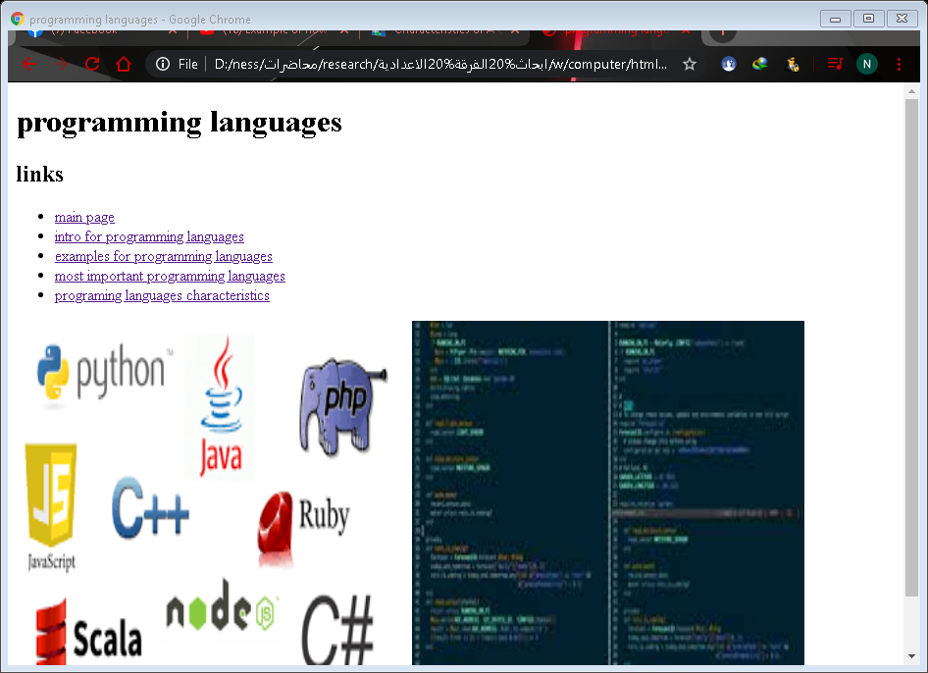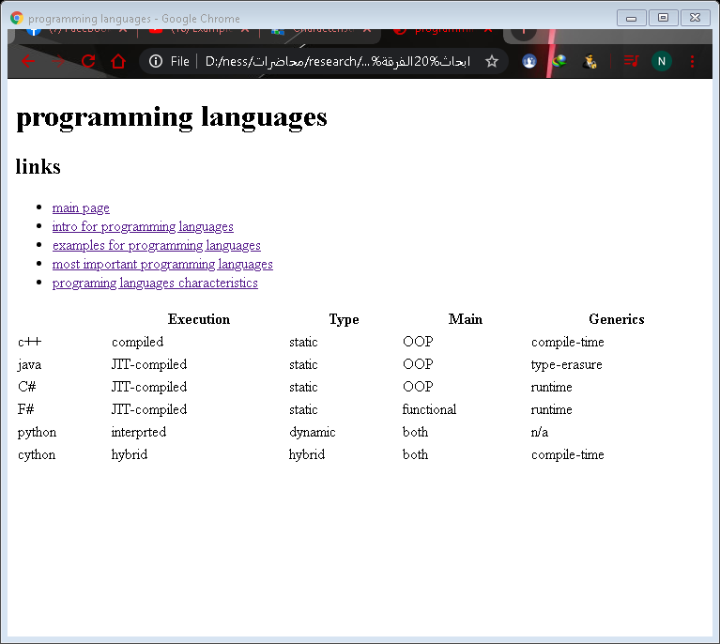Screenshots**:**

# Source code:

